**Fun Day I** Idea (rev1)

## Goal & Focus

To perform strength training activities in supplement to the core plan, engaging Justin's personal curiosity and desires

## Planning

Personal Curiosities

* Flexibility
* Range of Motion
* Combinatinatorial Lifting

Personal Desires

* Torso Strength, Definition
* Balance
* Core-Centered, by default and prep

## Activity Thoughts

Some fancy biceps item (1)

Some combinatorial shoulders item (1)

Some aggressive torso Item (2)

A few classic lifts omitted by Rob (2-3)

A grip and balance Item (1)

A novel or interesting chest item (1-2)

Total (8-9)

## Routine

*Goal:* Start Soft, end Hard, target supersets of 2-3

D:\Documents\Me\Fitness\Suppl\arrow pics\circular arrows.pngLying One-Arm Lateral Raise () (Shoulders/Back)

Dumbbell Squeeze Press () (Chest)

Farmer's Carries () (Grip)

D:\Documents\Me\Fitness\Suppl\arrow pics\circular arrows.pngPreacher Curl 21's () (Biceps)

Barbell Roll-Outs () (Torso)

Push-ups () (Chest)

D:\Documents\Me\Fitness\Suppl\arrow pics\circular arrows.png

Dumbbell Combo Walks () (Combinatorial)

Plank to Push-up (3x40) (Torso)

# Lift Details

## Biceps: Preacher Curl 21's

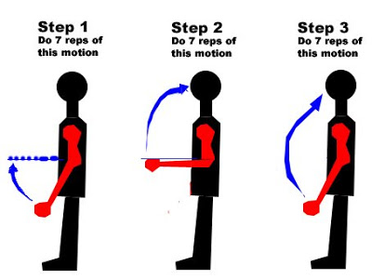

For this exercise, take the traditional preacher curl and break it down into three phases. To hit the lower end of the biceps, start at the bottom of the movement and raise the barbell halfway for 7 reps. Then do 7 reps from the top to the midway point to torch your upper biceps. Finally, complete 7 full-range-of-motion reps—which is where the pain really sets in—to complete one set of 21s.

Doing this 21-rep style will increase the time your muscles are under tension. You'll force extra blood into the muscles, signaling them to grow. That extra tension can also cause increased damage, which is another important signal for growth and repair.

## Torso: Plank to Push-up (3x40)

Source: <http://www.stack.com/a/core-strengthening-exercises>

Rotate starting side each ten. This core variation also incorporates movement but requires you to recruit more muscles to push them up the step. This one increases strength in both the core and triceps muscles, which is ideal for football players (linemen) who have to push off the ground.

**How to Perform**

* Get into a standard push-up position with a step-up board in front of you, adjusted to your level of strength
* While maintaining a tight core and back, lift one hand off the ground onto the board, followed by the other hand
* After both hands are on the board, lift the first hand off the board and place it back on the ground followed by the other hand. That is one repetition

## Chest: Push-ups

## Shoulders/Back: Lying One-Arm Lateral Raise

## Torso: Barbell Roll-Outs

Source: <http://www.stack.com/a/core-strengthening-exercises>

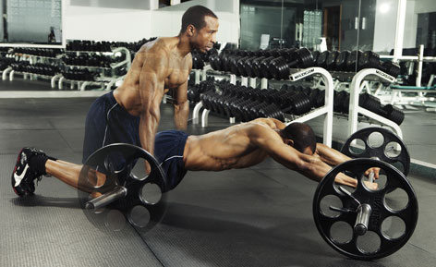

This is an alternate take on the classic Ab Wheel Roll-Out, forcing you to use your core strength in a stretched position. It also increases lower back and shoulder strength, which is very beneficial in most sports, because athletes are required to stretch their bodies to perform certain motions. A strong core helps prevent injury during these motions while assisting in producing force.

Get on your knees with a barbell on the floor in front of you and a 25-pound plate on each side. Grasp the bar with both hands about shoulder-width apart. While maintaining a neutral spine, slowly roll the barbell out in front of you until you are almost parallel to the floor. Using your core, slowly roll the barbell backwards until you return to the starting position. That is one repetition.

## Grip: Farmer's Carries

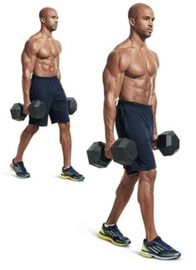

Typically done with 2 dumbbells or kettlebells, Farmer’s Carries mean you stand up with the weights and walk a certain distance or for a period of time. This adds motion to your grip, so not only are your forearms challenged but so are your core muscles, shoulders, and hips. Try walking 20’ and progressing to 40’ with heavy weights!

## Chest: Dumbbell Squeeze Press

Source: <http://www.menshealth.com/fitness/best-chest-exercises>

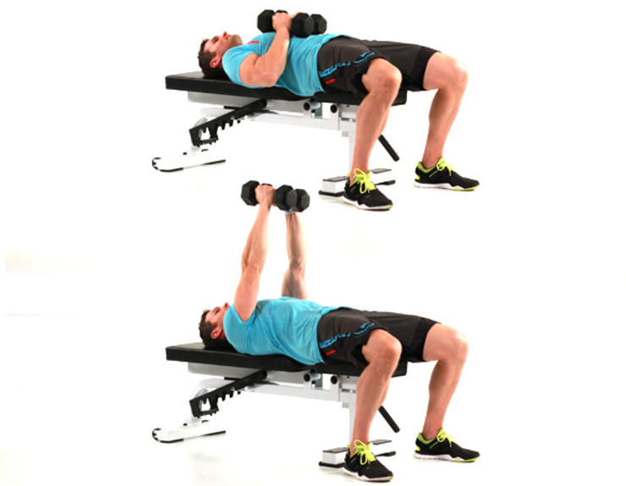

Squeezing the weights together during a chest press shifts all the stress onto your pectorals. This simple tweak engages them throughout the entire range of motion, which is a key factor in maximizing muscle growth.

## Combinatorial: Dumbbell Combo Walks

Source: <http://www.menshealth.com/fitness/dumbbell-pushup-walkout-t-rotation-row?cid=OB-_-MH-_-ABP>

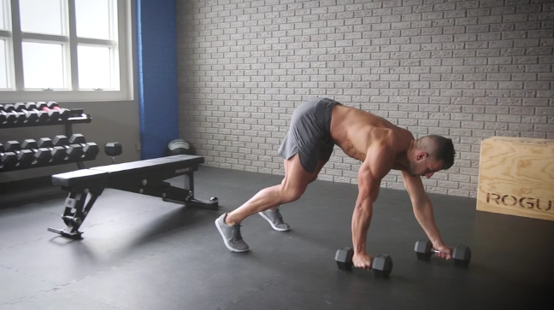

Dumbbells in hand, you’ll do 2 to 3 minutes of continuous work, flowing through pushups, walkouts, T-rotations, and pushup-position rows.

To make it even more challenging, Gaddour adds Fat Gripz—plastic sleeves that increase the thickness of your dumbbells’ handles—to the dumbbells. "They intensify the grip work and make the overall upper-body work much more challenging,” he says.

Watch the video above to see how to perform the drill. Do as many reps as you can in 2 to 3 minutes. Rest 1 minute. That’s 1 round. Aim for 3 to 5 rounds. “This drill will turn you into a gorilla—in a good way,” Gaddour says